Project 2 - Udagram Image Filter

1. Project is present on Github with 2 branches on url: <https://github.com/anubhav13103738/Project-2-UdagramImageFilter>
2. Project is deployed on elastic beanstalk with endpoint: [http://project-2-udagram-image-filter-dev.ap-south-1.elasticbeanstalk.com](http://project-2-udagram-image-filter-dev.ap-south-1.elasticbeanstalk.com/)

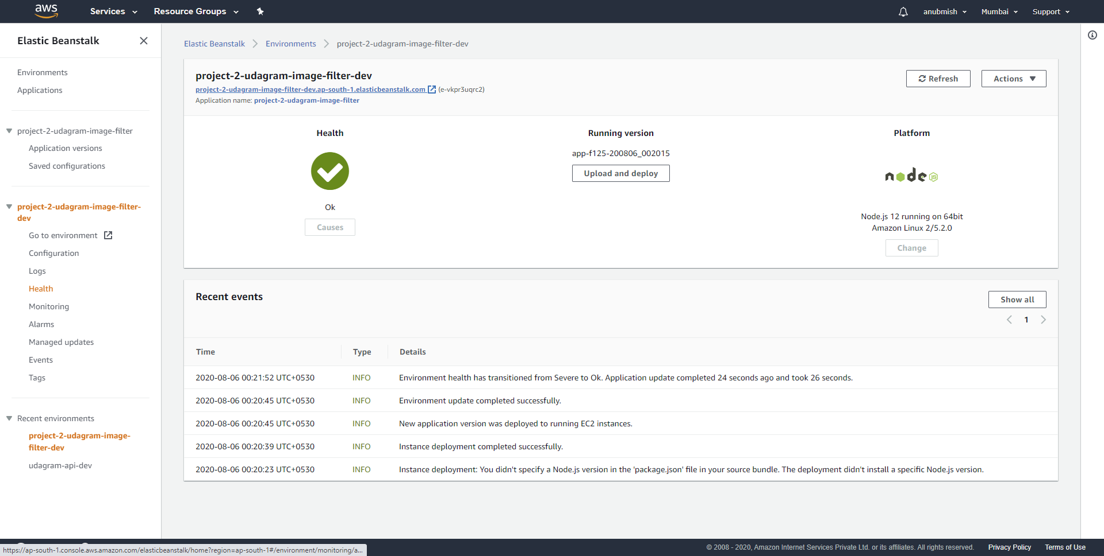

This screenshot is also present in the github repository on the url mentioned in point 1 above at root level with the name: **ElasticBeanStalkDeploymentScreenshot.PNG**

1. To run the service we need to use the API for image filter with the urls like:

http://*{{EB_URL}}*/filteredimage?image_url=*imageURL*

for e.g:

a. <http://project-2-udagram-image-filter-dev.ap-south-1.elasticbeanstalk.com/filteredimage?image_url=https://upload.wikimedia.org/wikipedia/commons/b/bd/Golden_tabby_and_white_kitten_n01.jpg>

b. <http://project-2-udagram-image-filter-dev.ap-south-1.elasticbeanstalk.com/filteredImage?image_url=http://hd.wallpaperswide.com/thumbs/green_nature-t2.jpg>